**Fabric and window treatments**

**IDEC 1045**

**FABRIC USE CONSIDERATIONS**

1. Replace the highlighted areas above.
2. Fill in the cells on the right in the table below.

## Week at a Glance

|  |  |
| --- | --- |
| **Week at a Glance** | |
| This week’s course learning outcomes (number and text) | **Text:** Designing Interiors 2nd, pages 471-474  **CLO03:** Explain fabric and drapery terminology, dye lot differences, pattern repeat, railroading and common care codes for cleaning and maintaining materials. |
| This week’s unit learning outcomes (number and text) | **Unit 1:**  1.5 Identify common fabric and drapery terminology and their uses  **Unit 2**:  2.1 Recognize trends in patterns and materials  2.2 describe dye lots, pattern repeat, fabric widths used in material selections  2.3 Identify “railroading” and how to apply it when selecting some patterns |
|  | |
| This week’s problem |  |
| How does this week’s problem fit into the course so far? | This week we are looking into some of the considerations needed to take into account when using fabrics. The student has learned about the construction of fabrics, basic pattern names and fabric content. Now we are going to go into some things a decorator needs to consider when selecting a fabric like different fabric widths, dye lots, what is a pattern repeat and how to calculate it, railroading, and some common terminology they should know. There is a lot to take into consideration when selecting a fabric for a window treatment and this week is to introduce the student to some of those things to be aware of. In the long run it will save costly mistakes and make the student more knowledgeable about some of the pitfalls they may run into. |
| List of topics and subtopics that will be covered to address this week’s problem | **Fabric definitions**: Thread count, dye lot, fabric widths, selvage, railroading, pattern repeat, pattern size  **Terminology:** some terms you should know  **Fabric trends:** 10 trends in window treatments |
| If this is a hybrid course, what topics and activities will be covered in-class to support the online content? |  |
| How does problem fit into the remaining weeks of the course? | This week prepares the student to be able to select appropriate fabrics for a window treatment and makes them aware of some of the pitfalls they may run into before deciding on a particular fabric to use for a window treatment. It also will alert them to doing their homework when working with a client to not make a costly mistake. |
|  | |
| Graded Assessment? | Yes. Fill out the Evaluation section below.  No. |

Introduction

|  |  |
| --- | --- |
| **Introduction to Week** | |
| Introduction | Description of content for this week:   * Explain what the user will learn * Describe the problem the user will be able to solve by the end of week * Answer the question “What’s in it for me (the learner)?”   Now that you know about the basics of fabric construction and general kinds of weaves and patterns it is time to look at some of the things you need to consider when selecting a fabric for a window treatment. It is important to be informed about what to look out for when selecting fabrics for a window treatment to avoid costly mistakes when deciding on a fabric for a client and when ordering fabric for custom treatments. The more knowledge you have about fabrics the more confident you can be when selecting the appropriate on to use. The more you can learn about windows and fabrics, the more professional you can be with your client and the more successful you will be using fabrics. |
| Learning Outcomes | Write out the week’s unit learning outcomes here (number and text).  **Unit 1:**  1.5 Identify common fabric and drapery terminology and their uses  **Unit 2**:  2.1 Recognize trends in patterns and materials  2.2 describe dye lots, pattern repeat, fabric widths used in material selections  2.3 Identify “railroading” and how to apply it when selecting some patterns |
| Other relevant announcements/ reminders | Insert notes on assignments and/or anything out of the ordinary.  Note: You can also add an image here for a front cover page look and feel.  Istock id: 482710839  C:\Users\Linda\Downloads\482710839.jpg |

****************** Beginning of instructional content ************************

Fabric definitions:

When selecting any fabric for a window treatment it is important to select the correct one for that particular window. Fabric weight that we talked about last week is just one of the considerations and here we will talk about some of the other things to be aware of for a successful treatment.

### Thread count

When determining fabric softness and durability we use thread count as one of the determining factors. Thread count is also known as TPI meaning the number of threads per square inch of fabric often for bedding fabrics. Good quality sheeting starts at 180 to over 200. The higher the thread count the softer the fabric will feel and likely will wear better as well.

Some extremely high thread counts that are typically over 500 can be misleading as some companies count each ply of yarn to appear to have a higher thread count instead of the number of threads (threads can have 2, 3 or more yarn twists) so be wary of really high thread counts can be misleading.

Istock id: 597960556

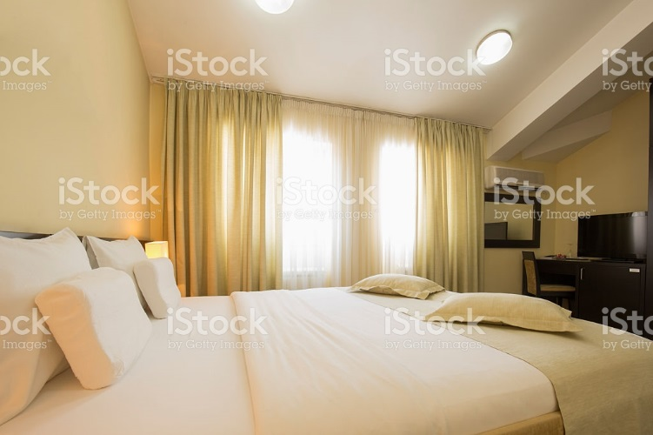

### Dye lot

Dye lots are important to keep in mind when ordering or purchasing fabric. Like all manufactured items from carpet, paint, wallpaper, balls of yarn for knitting and of course all fabrics, there can be slight differences in colouring between manufacturing runs. Fabric is usually made in 700 yard runs and a record is taken during the dying process that shows the fabric got the same dye at the same time. Each run has a unique number and stamp on the label before shipping.

When ordering fabric it is necessary to make sure you order enough material to compete the job. If you have to order more, it may not match. Also if you had a client who ordered fabric for one window now and another window later, there again may be a dye lot difference meaning a slight colour difference. Each run of dyed fabric has a number on it showing which batch it came from. There can even be differences from the sample swatch to the actual fabric you would get when ordered. I always suggest ordering a bit more fabric than you actually need to give yourself a bit of a buffer in case of fabric flaws or miscalculation on your part. Better safe than sorry should be your motto.

This website <https://en.wikipedia.org/wiki/Dye_lot> shows how a dye lot tag looks.

### Selvage

Selvage refers to the unfinished ends of a roll of fabric. These ends sometimes hold information from the manufacturer like fabric content and colours used in a pattern. We will refer to this more in future lessons.

Istock id: 140408629

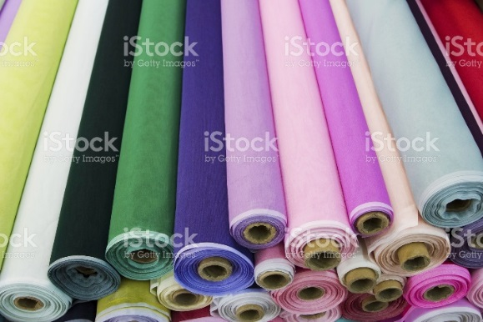

### Fabric width

A fabric width is the finished fabric distance across a roll of fabric perpendicular to the selvages (not including selvage edge). It is measured on a cloth that is free of folds or wrinkles and with no tension on it.

You need to know the width of a fabric in order to figure out the yield it can provide as the narrower the fabric, the more yardage is required. Fabric widths can vary from 48” wide to 60”+. Sheers range from 54” up to 106” in width on average. Standard drapery and upholstery fabric widths are generally 54” wide. The width will be listed on a bolt if you are purchasing it that way and it is listed on the label attached to the back of a fabric in a fabric sample book. Some high-end silks and linens can be narrower at 42-45” wide. Drapery lining ranges from 48” – 54” – 60”. You can also get extra wide drapery lining from 115 – 126” wide.

Since there are so many width possibilities it is important to make sure that the width is known early on in your search.

### Railroading

Railroading is referring to how the fabric is printed either vertical or horizontal. It is often used

By the upholstery industry to allow a fabric to be used in one piece across the length of a piece of furniture without seams. Since many upholstered fabrics can also be used for window treatments it is important to check if it is “railroaded” or “up the roll”. Up the roll refers to a pattern that is vertical between the selvage edges and a railroad pattern is one that is horizontal between the selvage. When purchasing fabric on a bolt in person you can see which way the pattern runs. When ordering from a sample fabric book, you MUST check the back of the sample to see if it is railroaded. Sometimes the fabric book will show a fabric that has a horizontal pattern but they will show it vertical in the book!

This sample of a fabric is shown up the roll. This is the way it is printed lengthwise on the roll.

Istock id: 500331864

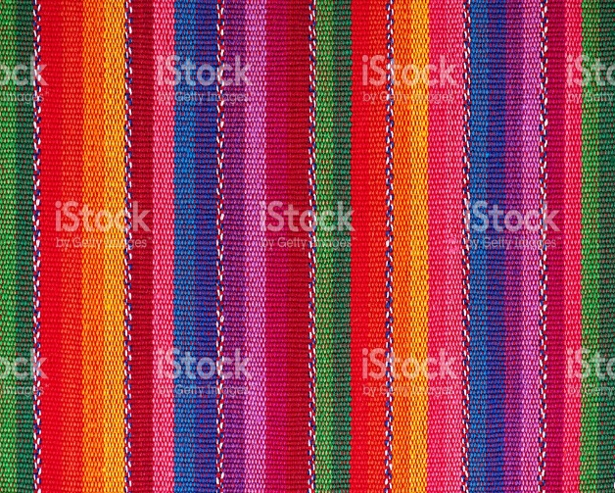

This sample of a fabric is shown railroaded meaning that the stripe is horizontal between the selvage edges

Istock id: 500331864

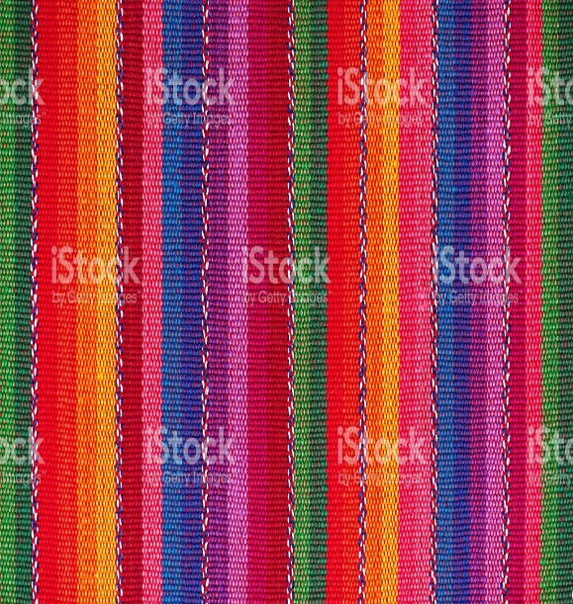

NOTE: I tell you this because I made this costly mistake only once early in my career! I ordered a stripe expecting it to be vertical for a window treatment. My seamstress called me to inquire if I really wanted a horizontal stripe. To my horror I realized that the stripe was going the wrong way. I had to return the fabric that cost me several hundred dollars in a re-stocking and shipping fees as I ordered about 25 yards. I then had to inform the client and reselect a fabric. It was a very expensive and embarrassing experience for me and an annoyance for my client that I will never make again!

Check out this website for a good example of railroading fabric.

<http://www.sailrite.com/What-is-Railroaded-Fabric>

This YouTube video explains railroading <https://www.youtube.com/watch?v=RTOUhfO1_sU>

Most fabrics are not railroaded, however if ordering from a sample book make sure to check that the pattern (often a stripe) is running the way you want it to.

## Pattern repeat and size

A pattern repeat is the measurement of the distance between any given point in a design and where that exact point first appears again. This can be vertical or horizontal. In most cases with a drapery repeat you will be concerned with the vertical repeat. The larger the repeat the more fabric is required. This pattern repeat is very evident when wallpapering and having to match up the pattern with the next length when applying to the wall.

Fabric patterns typically repeat in increments of 3” up to a maximum of 27”. A very small pattern may repeat every 3 inches while a medium patter may repeat about every 15”. Large pattern fabrics will repeat from 24-27”. That is ½ a yard or more and this will become important to keep in mind when we get to the lesson on measuring and calculating fabric amounts for windows.

Check out this video on pattern repeats

<https://www.youtube.com/watch?v=y6Ee2rS9vj8>

**Small** repeats can be any pattern from leaves, florals and geometrics and work better for smaller treatments, valances and sometimes shades instead of full length drapery due to the scale. Sometimes small patterns can look more like a texture on window treatment rather than a pattern, especially if they are viewed from a distance. Small prints can give an illusion of tactile dimension.

Istock id: 513364610

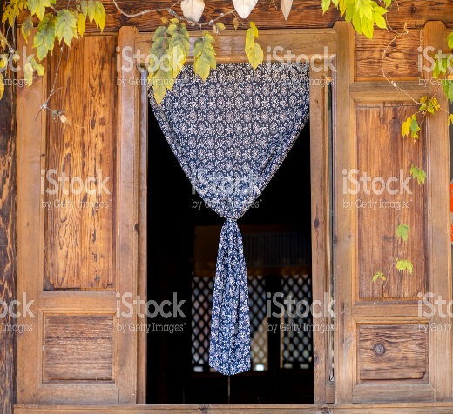

**Medium** repeats can be any pattern and are suitable for all types of window treatments. Their size can allow the pattern to be more visible from distances. This size is the most common size with a wide selection of patterns to choose from.

Istock id: 172449456

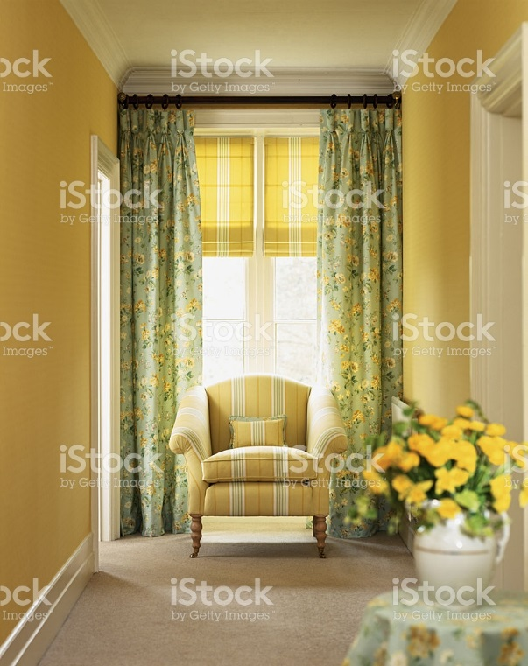

**Large** repeats are usually best for full length drapery to encompass the pattern. Some extremely large prints once pleated into a drape will not show the actual pattern as much and offer colour and texture rather than pattern, however the majority of large patterns add a great dynamic element to a treatment. Overall large prints can be a focal point and appears to move towards you drawing attention.

Istock id: 174814831

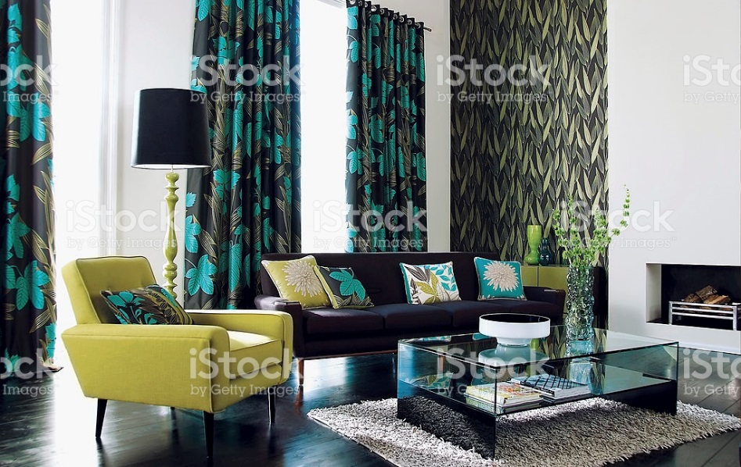

## 

## Terminology:

There are lots of terms used in window treatments that you should be aware of. Some of the more common will be shown here for you to become familiar with.

### Pattern:

We have gone over some of the more basic kinds of pattern previously. These are some terms you may come across as you travel through the world of fabric as well.

**Batik** is a kind of hand dyed fabric that creates coloured designs using wax. That resists the dye over some areas of the cloth. It is popular in Indonesian areas creating colourful designs.

Istock id: 183882750

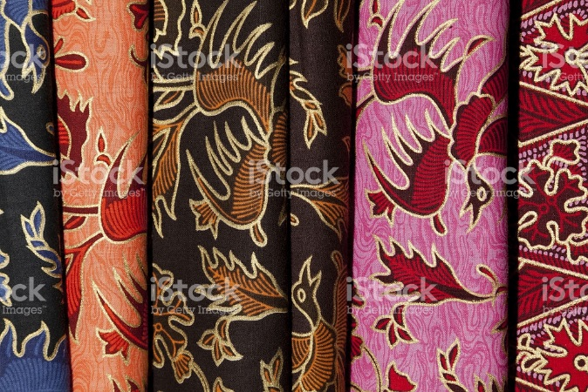

**Ombre** is a pattern that gradually ranges in tones from light to dark colour.

Check out the Robert Allen website for Ombre examples…

<https://www.robertallendesign.com/catalogsearch/result/?q=ombre>

**Directional** is a pattern that runs up and down or side to side rather than an all over look.

**Striae** is a streaked stripe effect that is more textural in appearance.

**Flame stitch** is similar to a chevron pattern but larger and usually multi coloured to imitate the looks of flames in a fire.

Istock id: 643500646

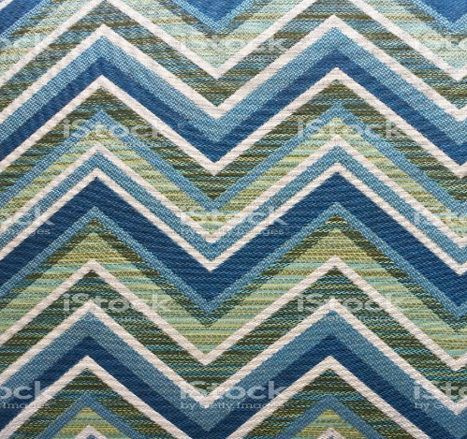

**Conversational** pattern contains recognizable object like animals, skulls or even clocks or other objects that have some kind of theme. This kind of print is also known as an object print.

**Scenic** patterns are often of a landscape relating to nature.

### Window treatment:

**Blinds** are often referred to as hard treatments made from horizontal or vertical slats. They can be made from metal, wood or heavy fabric that are held together by strings or cords. They can be operated manually or by remote control.

Istock id: 184862328

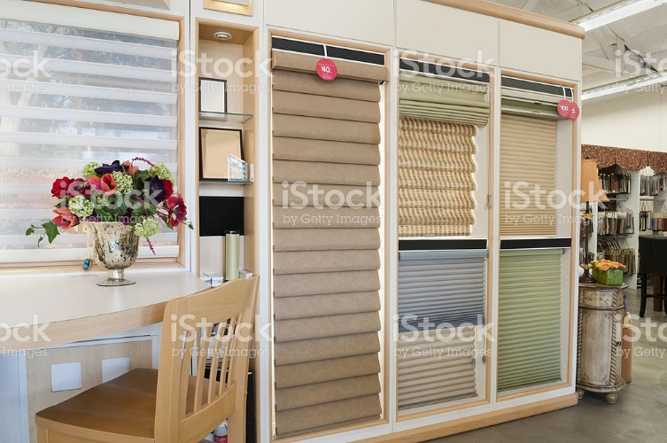

**Cellular shade** is a pleated hard treatment sometimes of a honeycomb construction used for privacy and insulation on a window.

Istock id: 503303906

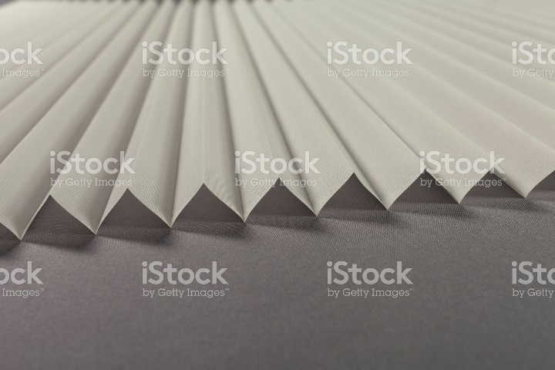

**Cornice** in draperyis usually upholstered in a fabric over a hard surface that covers the top of a window. It can be used alone or in combination with other treatments for a layered look.

Istock id: 187991734

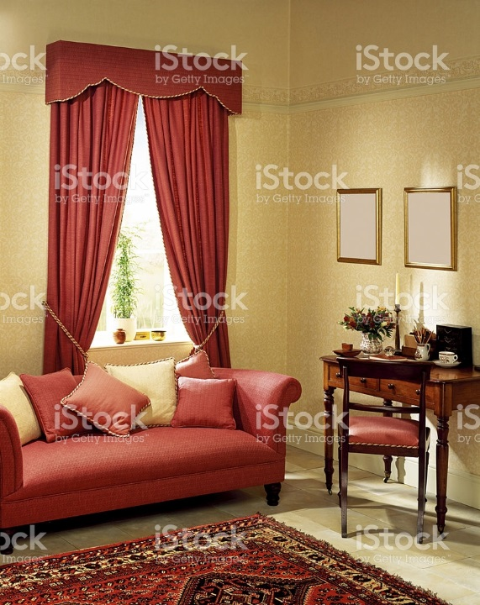

**Curtain** is a term for an unlined stationary kind of window treatment. Often shorter in length than a drape and sometimes held back with a tieback. Today curtains are mostly found on kitchen windows or doors.

Istock id: 96782263

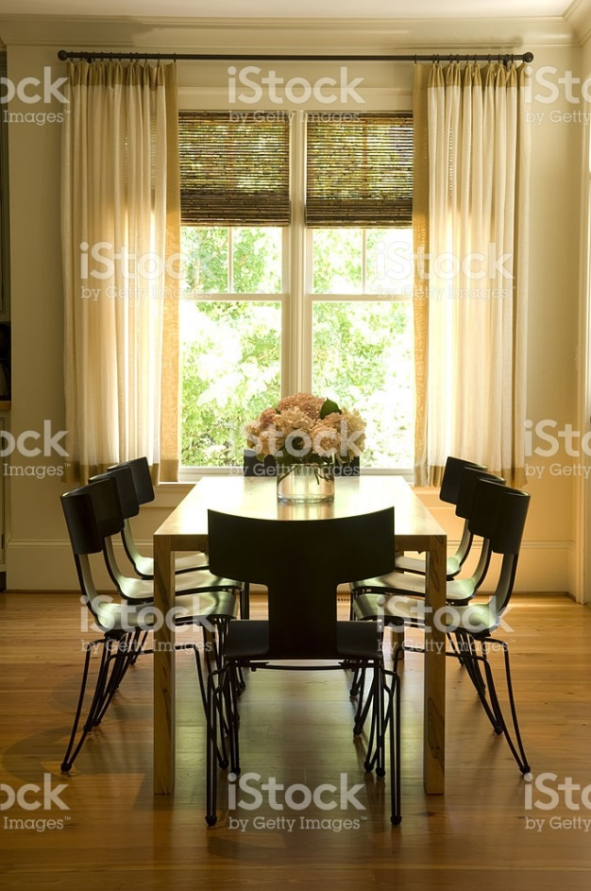

**Drapery** are lined window treatments usually hung from floor to ceiling using an opaque fabric. They can have many pleat and hanging styles.

Istock id: 480919818

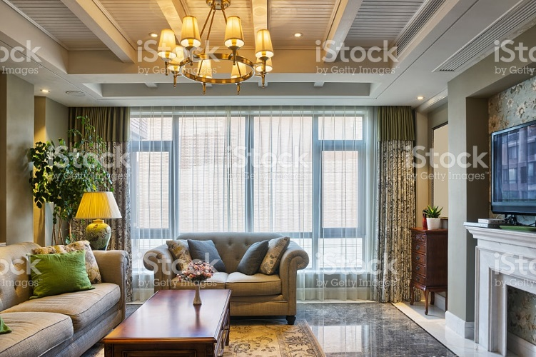

**Hand** is a tactile reference to how a fabric feels and the way it can drape or fold into a window treatment. You need to feel the fabric to understand and how it will hang, test its weight and texture.

Istock id: 531626884

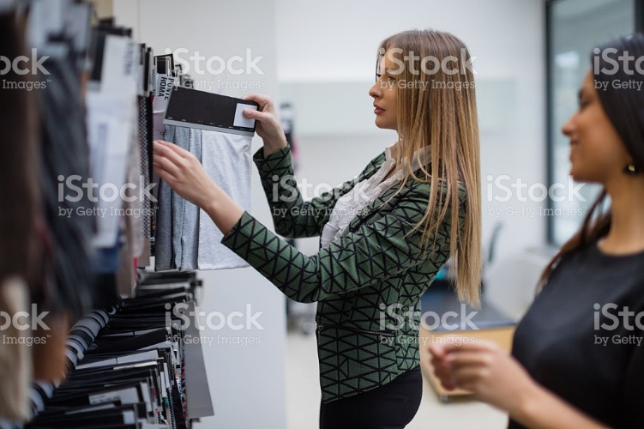

**Panel** is a single curtain or drape. Standard window treatments need two panels to create a pair on a window.

Istock id: 600132494

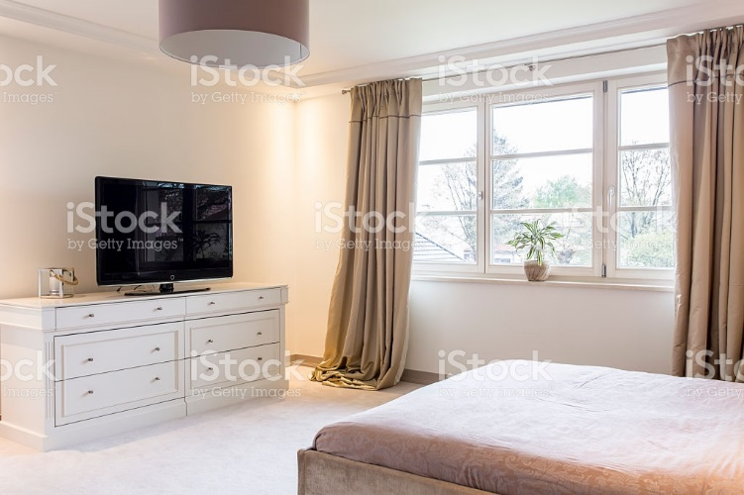

**Shade** or shades refers to blinds that cover a window using an opaque fabric that can be pleated or rolled.

Istock id: 173635507

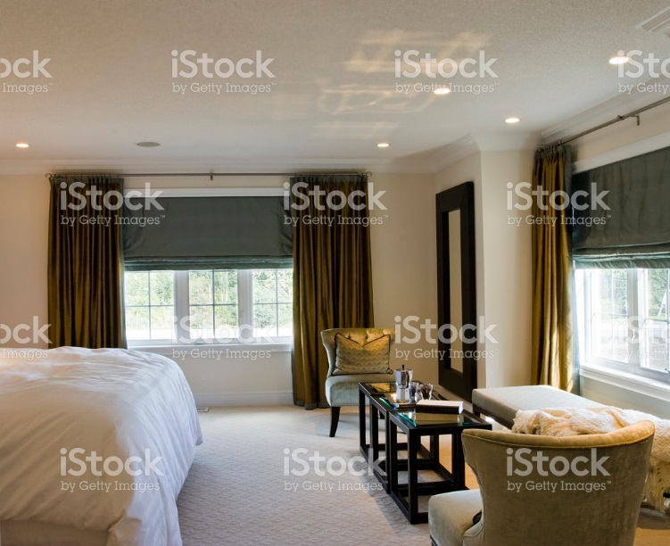

**Sheers** are a translucent fabric that is lightweight used to soften light coming into a room. They can be used on their own or layered with another treatment to obscure the view from outside and soften the light coming into a room. Be aware of using strong colours on the window for this treatment as it will change the colour of the light coming into the room. Overall it is best to stick to neutral shades so the colour of the room is not as affected by the colour of the fabric.

Istock id: 523173782

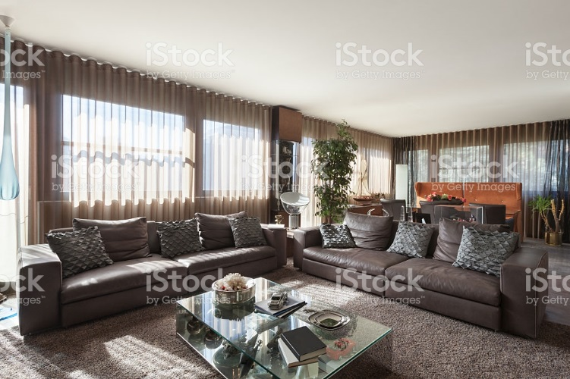

**Tailored** means a treatments that are simple and with straight lines. This is a very timeless method of using drapery panels or valances.

Istock id: 181074014

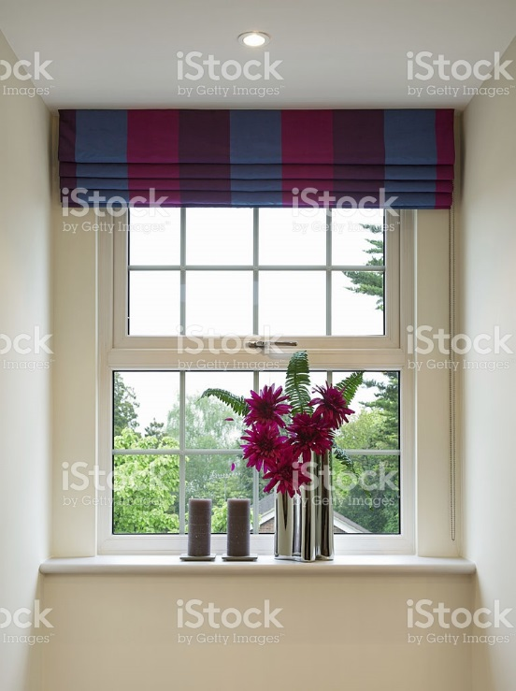

**Valances** are window treatments that hang from the top part of a window that can be used alone or layered with blinds, or drapery. They are decorative accents or used to cover drapery hardware.

Istock id: 157615411

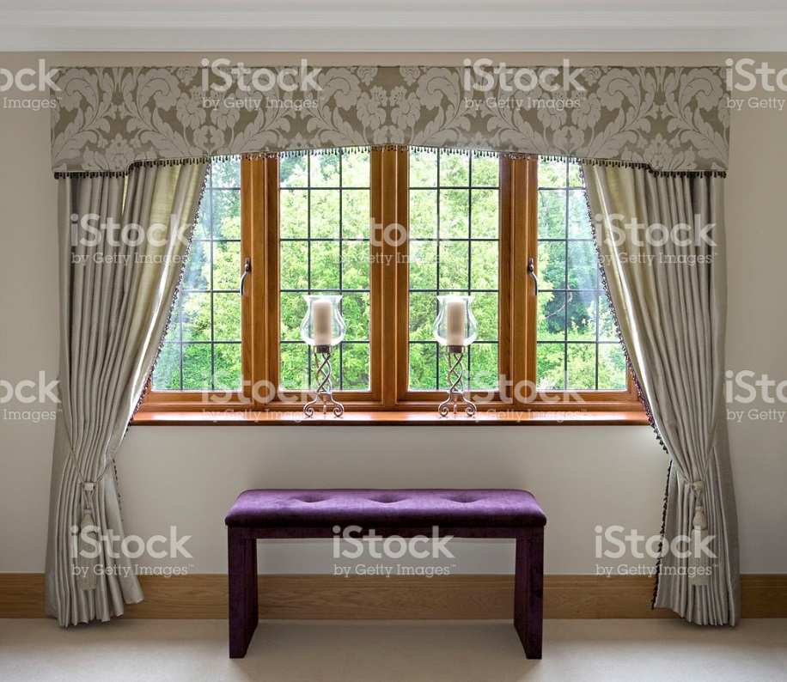

This website offers a great deal of terminology that you will find interesting.

<https://www.dwfcontract.com/Drapery--Window-Covering-Blog/bid/34627/Glossary-of-Drapery-Terminology>

Fabric trends**:**

As with any decorating era, trends change in the window treatment industry as well. Fabrics that are current trends reflect the contemporary style of décor over the past decade and influences from other parts of the world. We get influences from what is happening in our societies, colour trends and textures that are popular as well. The following are 10 current fabric trends that you should be able to recognize.

**1. Natural fibers** like cotton, linen and especially silk are very popular and gaining each year. There is a strong trend to use renewable resource materials.

Istock id: 518898020

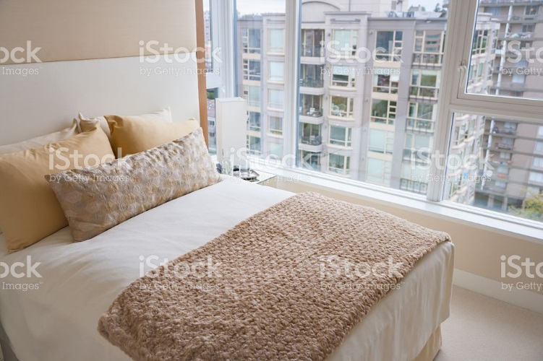

**2. Grey and bronze** fabric colours offer the popular urban look so evident in much of the current décor trends. I am sure you have all seen the trend to these colours in stores and magazines as well as TV shows. The grey tones are becoming very common for walls and flooring and naturally they would appear in fabrics for upholstery and window treatments as well. These tones together have a chic appearance and work for all styles of decor.

Istock id: 517992284

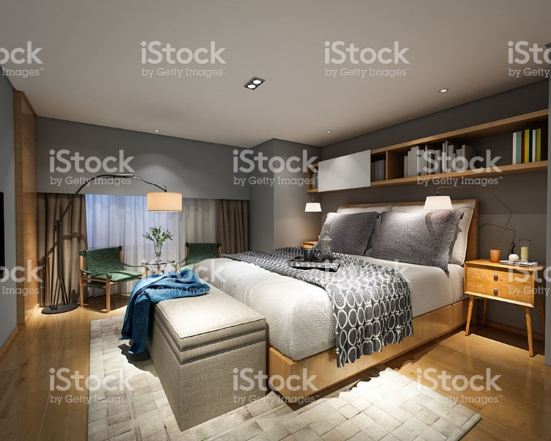

**3. Bold patterns** often in black and white make a bold statement and are a welcome change to all the plain fabrics from the past decade. They mix well with the contemporary look we have had. Bold patterns make a statement and so you don’t need a lot of it in a room to draw attention. They are a great addition to a room with no pattern and are growing in popularity to add a new focus for window treatments. You already see this in wall paper that has large bold pattern used like art on one wall and on window treatments they can be a wonderful focal point.

Istock id: 498398241

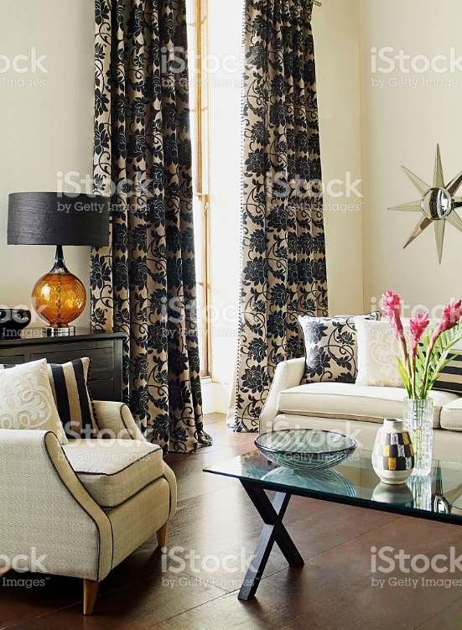

**4**. **Metallic** used in threads within a fabric like gold, silver, bronze and copper add some sheen and interest. That little bit of sparkle in a fabric can really add some interest to a fabric. It doesn’t take much to add glamour to a material. It is also fun to mix your metals in a room. The old way of having all fixtures being the same colour has moved to a more eclectic appreciation of mixing brass, silver, copper and wrought iron in different areas of the room. For example you may have some brass or gold on mirror frames, wrought iron on curtain rods and then some copper thread in your window treatment. Look for fabrics with some metallic enhancement and see how a little can be exciting in a window treatment fabric.

Istock id: 96336885

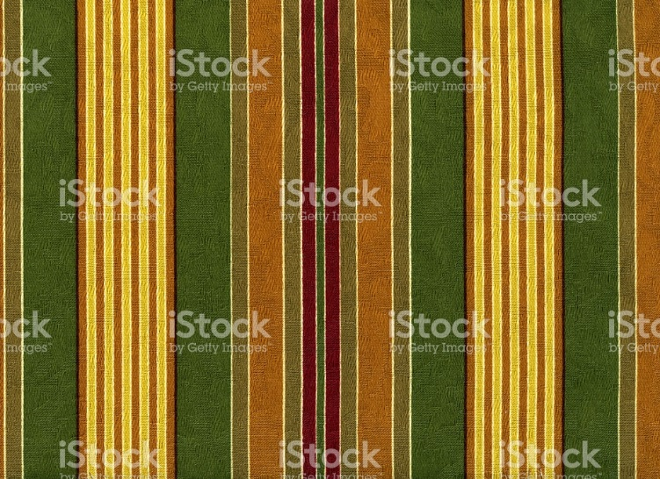

**5. Embroidered** elements add elegance and charm to a window treatment and is a nod to the traditional style returning more over the next decade. Often seen in silk and sheers, it can be an exciting element to a window treatment. With the trend becoming more traditional you are bound to see embroidered fabrics increase as well in accent cushions and bedding. Embroidered can be fabrics like crewel, eyelet and lace.

Istock id: 182148968

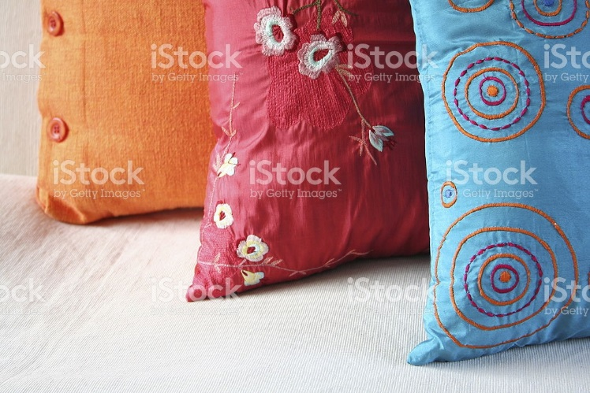

**6. Prints** of all kinds are also returning more over the next few years. You will see more floral returning along with all other kinds of prints returning. This is evident now in accessories and will flow into all areas of décor. They will not be like your grandmothers era but more sophisticated and a welcome addition to your decorating portfolio.

Istock id: 174494836

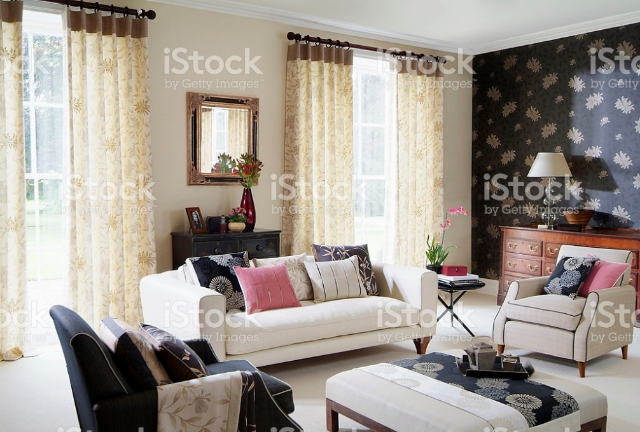

**7. Leather** is still extremely popular and while common in furniture and headboards, they can give a very interesting addition to window treatments in upholstered cornice for a tailored look. Some vinyl looks have a great leather texture at a lower cost. We see a lot of leather in furniture like benches, dining chairs, club chairs and sofas and there is no reason that we cannot add some leather or faux leather to windows as well in certain structured treatments.

Istock id: 172123465

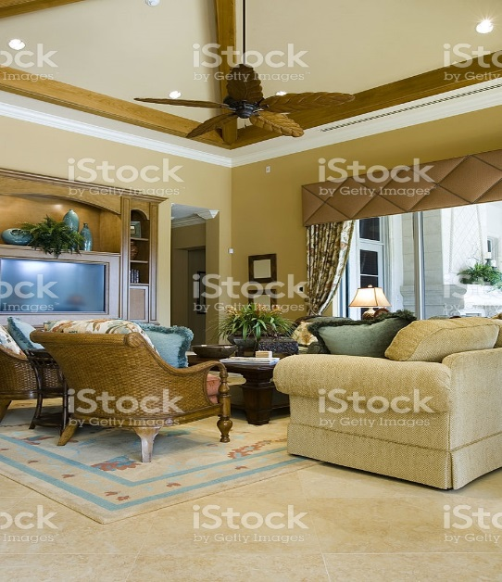

**8. Textured semi sheer** often has a great pattern from traditional to contemporary that can add a great look to windows such as the urban lofts with the large windows they offer as well as in any home. The new sheers are very exciting and nothing like 20 or 30 years ago. Today there are amazing textured sheers on the market for all styles of décor. A semi sheer can also add more privacy than a delicate sheer will as well as soften the light coming into the room. If you need more light control you can always add a blind underneath. Textured sheers don’t just have to be drapery but can also come in shades and blinds as well as many patterns woven into them to create the look you are wanting to achieve.

By Linda Guthro

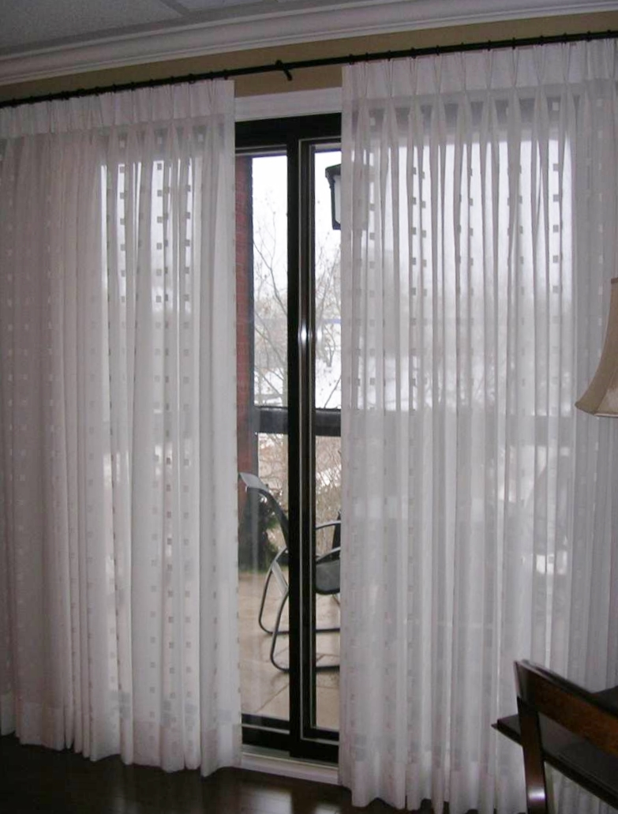

**9. Colour** of course is always important trends and today we are using the hot colour tones and pairing them with the neutrals we have been using puts new life into our home colour scheme. While colours do have trends, you can find all colours in window treatment to go with your décor.

Istock id: 171266032

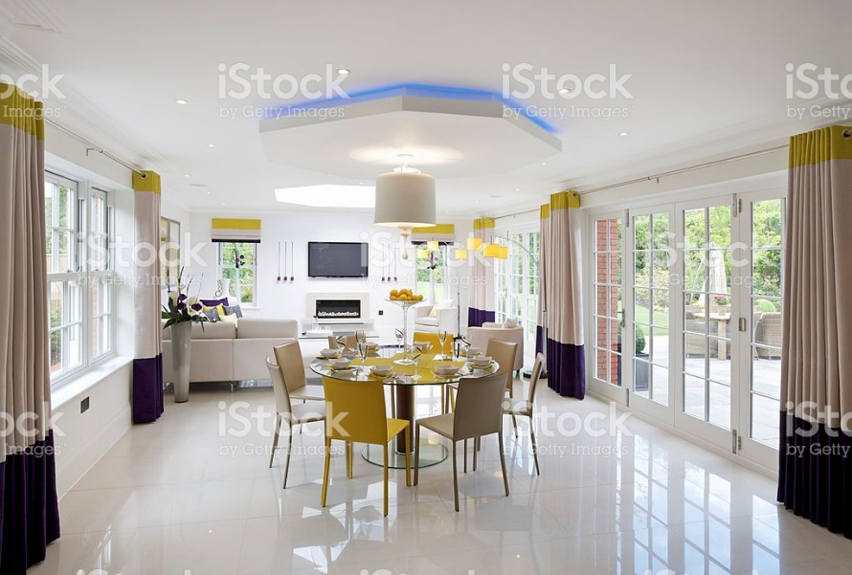

**10. Global Fusion** is the mix of different colour and style influences from around the world for a bit of a funky and individual look. Our world is getting so small and we are travelling to and being influenced by many other cultures so why not bring some of it home?

Istock id: 88621356

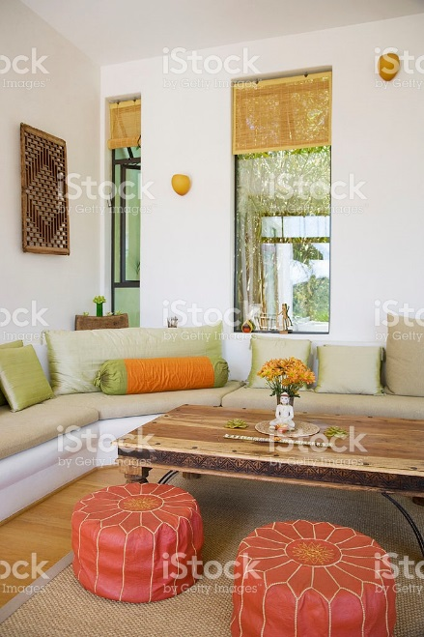

## Conclusion:

We have gone over a lot of terms and items this week. If you have the chance I encourage you to go looking for some of the examples we talked about this week. Seeing and feeling the actual thing is so much better than just reading about it. Fabric is such a tactile experience so visit drapery and other fabric stores and see what you can find. Fabrics are very exciting for decorators and mixing textures, patterns and colours in a home can make for a more interesting environment. Have fun searching for some of your favourites!

I would like to add a discussion board to have students share their favourite trends, kinds of fabric and patterns. Or maybe we could add a little activity to recognize some kinds of patterns?

********************* End of instructional content *************************